Create the following table.

Supplier-(scode,sname,scity,turnover)

Part-(pcode,weigh,color,cost,sellingprice)

Supplier_Part-(scode,pcode,qty)

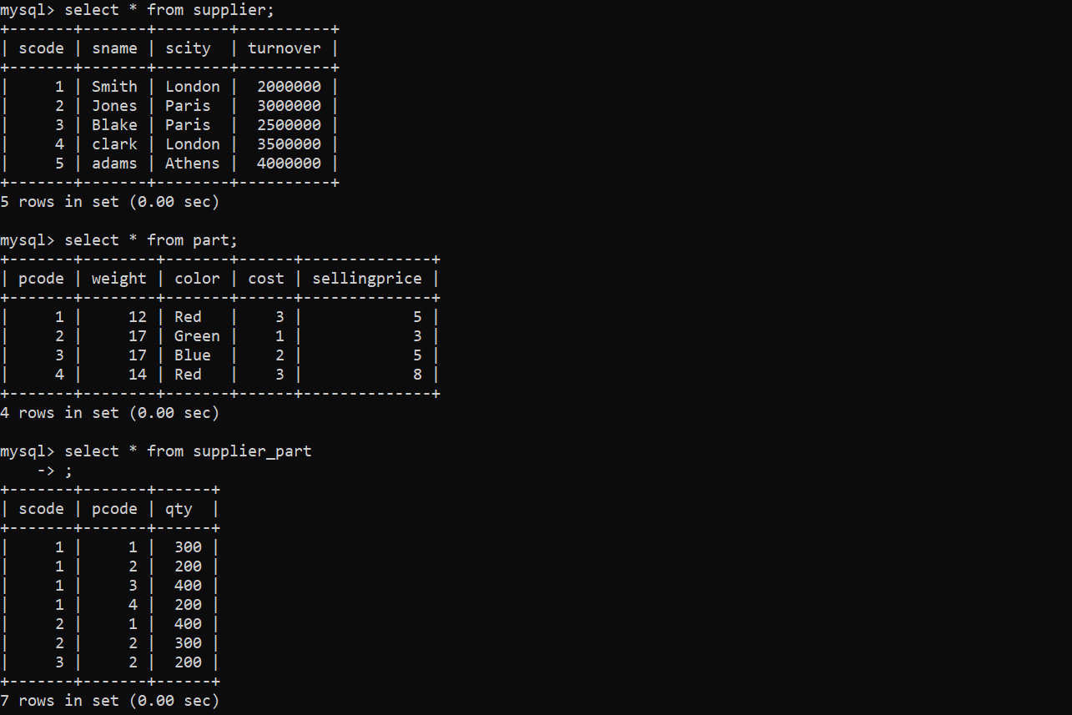

Ques1: Get the supplier number and part number in ascending order of supplier number.

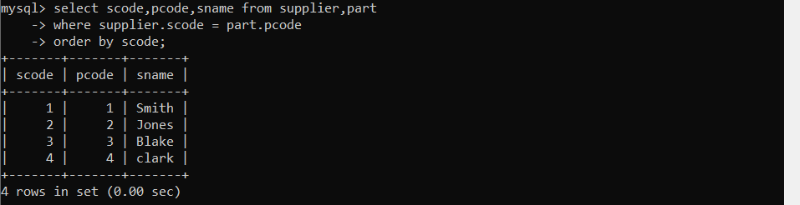

Ques2: Get the details of supplier who operate from Bombay with turnover 50.

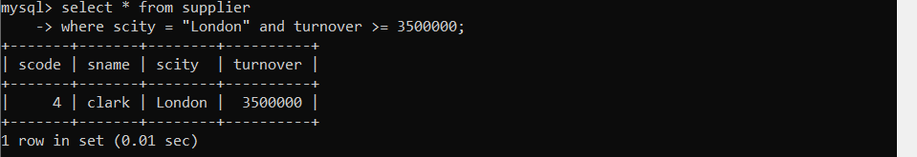

Ques3: Get the total number of suppliers.

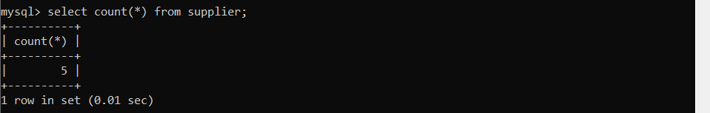

Ques4: the part number weighing between 25 and 35.

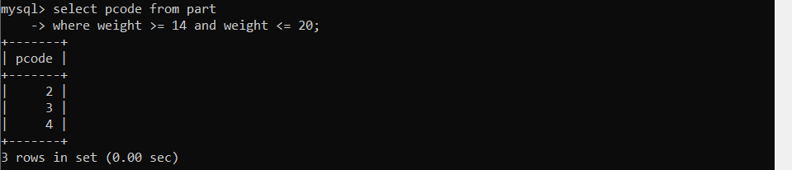

Ques5: Get the supplier number whose turnover is null.



Ques6: Get the part number that cost 20, 30 or 40 rupees.

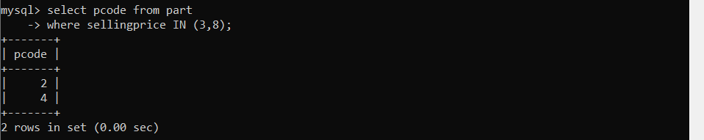

Ques7: Get the total quantity of part 2 that is supplied.

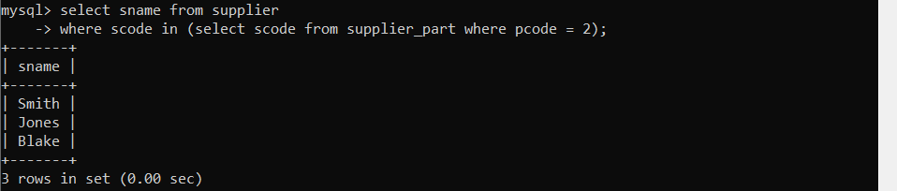

Ques8: Get the name of supplier who supply part 2.

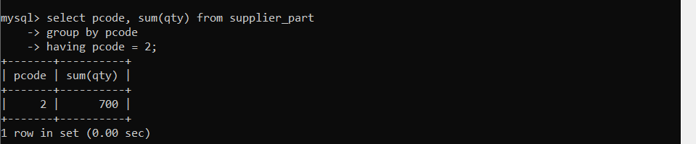

Ques9: Get the part number whose cost is greater than the average cost.

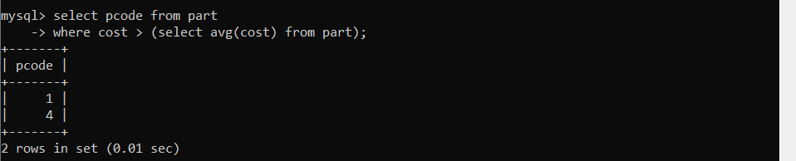

Ques10: Get the supplier number and turnover in descending order of turnover.

